==========================================================

**Міністерство освіти і науки України**

**Національний технічний університет**

**«Дніпровська політехніка»**



**ЗВІТ**

**про виконання лабораторних робіт**

**з дисципліни**

# «Алгоритми та структури даних»

**Лабораторна робота № 7**

Виконав:

студент гр. 124-19-2

Моторний Андрій Сергійович

Прийняв:

викладач. каф. ФІТ

Сергеева Екатерина Леонидовна

**Дніпро**

**2020**

Звіт

1)Лабораторна робота №7

## 2) Структура даних : стек, черга, дерева

3)Варіант №12

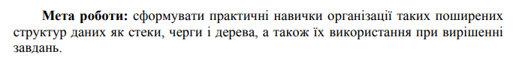

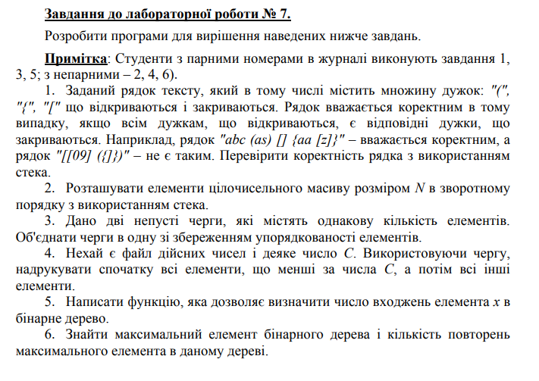

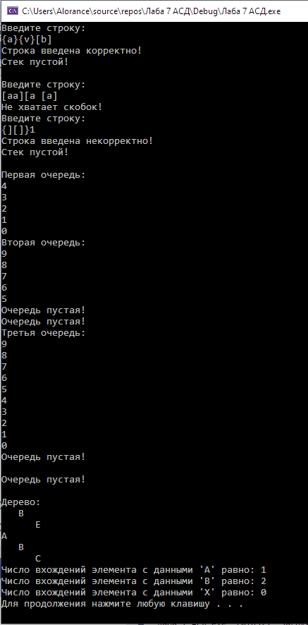

#include<iostream>

#include<Windows.h>

using namespace std;

enum Flag

{

Catch_up,

Put_down,

Not_defined

};

struct Stack_node

{

private:

char data;

Stack_node* next;

friend void push_Stack(Stack_node*& head, char data);

friend int pop_Stack(Stack_node*& head);

friend void clear_Stack(Stack_node*& head);

friend void check_String(Stack_node*& head, char* str);

};

void push_Stack(Stack_node*& head, char data)

{

Stack_node* New = new Stack_node();

New->data = data;

New->next = head;

head = New;

}

int pop_Stack(Stack_node*& head)

{

if (head == nullptr)

return printf("Стек пустой!\n");

else

{

char value;

Stack_node* toDelete = head;

head = toDelete->next;

value = toDelete->data;

delete toDelete;

return value;

}

}

void check_String(Stack_node*& head, char* str)

{

Flag check = Not_defined;

int length = strlen(str);

for (int i = 0; i < length; i++)

{

if (str[i] == 40 || str[i] == 91 || str[i] == 123)

{

push_Stack(head, str[i]);

}

else if (str[i] == 41)

{

char symbol = pop_Stack(head);

if (symbol == 40)

check = Catch_up;

else

{

check = Put_down;

break;

}

}

else if (str[i] == 93)

{

char symbol = pop_Stack(head);

if (symbol == 91)

check = Catch_up;

else

{

check = Put_down;

break;

}

}

else if (str[i] == 125)

{

char symbol = pop_Stack(head);

if (symbol == 123)

check = Catch_up;

else

{

check = Put_down;

break;

}

}

}

if (head != nullptr)

{

cout << "Не хватает скобок!" << endl;

return;

}

if (check == Catch_up)

cout << "Строка введена корректно!" << endl;

else if (check == Put_down)

cout << "Строка введена некорректно!" << endl;

else

cout << "В строке отсутствуют скобки!" << endl;

}

void clear_Stack(Stack_node*& head)

{

if (head == nullptr)

cout << "Стек пустой!\n" << endl;

else

{

Stack_node* toDelete = head;

while (head != nullptr)

{

head = toDelete->next;

delete toDelete;

}

}

}

struct Queue_node

{

private:

char data;

Queue_node* next;

friend void push_Queue(Queue_node*& first, Queue_node*& last, char data);

friend int pop_Queue(Queue_node*& first, Queue_node*& last);

friend void Merge_Queues(Queue_node*& New_first, Queue_node*& New_last, Queue_node*& first, Queue_node*& last, Queue_node*& first2, Queue_node*& last2);

friend void clear_Queue(Queue_node*& first, Queue_node*& last);

friend void print_Queue(Queue_node*& last);

};

void push_Queue(Queue_node*& first, Queue_node*& last, char data)

{

if ((first == nullptr) || (last == nullptr))

{

Queue_node* New = new Queue_node();

New->data = data;

New->next = last;

last = New;

first = last;

}

else

{

Queue_node* New = new Queue_node();

New->data = data;

New->next = last;

last = New;

}

}

int pop_Queue(Queue_node*& first, Queue_node*& last)

{

if (first == nullptr)

return printf("Очередь пустая!\n");

else

{

char value;

Queue_node* toDelete = first;

Queue_node* temp = last;

while ((temp->next != first) && (temp->next != nullptr))

temp = temp->next;

if (temp == first)

{

value = toDelete->data;

delete toDelete;

first->next = nullptr;

first = last = nullptr;

return value;

}

else

{

first = temp;

value = toDelete->data;

delete toDelete;

first->next = nullptr;

return value;

}

}

}

void Merge_Queues(Queue_node*& New_first, Queue_node*& New_last, Queue_node*& first, Queue_node*& last, Queue_node*& first2, Queue_node*& last2)

{

char Data, Data2;

bool flag = false, flag2 = false;

while (!flag)

{

Data = pop_Queue(first, last);

if (Data == 16)

flag = true;

else

push_Queue(New_first, New_last, Data);

}

while (!flag2)

{

Data2 = pop_Queue(first2, last2);

if (Data2 == 16)

flag2 = true;

else

push_Queue(New_first, New_last, Data2);

}

}

void print_Queue(Queue_node*& last)

{

if (last == nullptr)

cout << " " << endl;

else

{

Queue_node* temp = last;

while (temp != nullptr)

{

cout << temp->data << endl;

temp = temp->next;

}

}

}

void clear_Queue(Queue_node*& first, Queue_node*& last)

{

if (last == nullptr)

cout << "Очередь пустая!\n" << endl;

else

{

Queue_node* toDelete = new Queue_node();

while (last != nullptr)

{

toDelete = last;

last = toDelete->next;

delete toDelete;

}

first = nullptr;

}

}

struct Tree_node

{

private:

char data;

Tree_node* left, * right;

friend Tree_node* create_tree(int size, char* arr, int& index);

friend void distruct(Tree_node*& root);

friend void print_Tree(Tree_node*& root, int number);

friend int search_entries(Tree_node*& root, int& quantity, char data);

};

Tree_node* create_tree(int size, char* arr, int& index)

{

if (size <= 0)

return nullptr;

else

{

int size_left, size_right;

Tree_node* new_root = new Tree_node();

size_left = size / 2;

size_right = size - size_left - 1;

new_root->data = arr[index];

index++;

new_root->left = create_tree(size_left, arr, index);

new_root->right = create_tree(size_right, arr, index);

return new_root;

}

}

void distruct(Tree_node*& root)

{

if (root != nullptr)

{

distruct(root->left);

distruct(root->right);

delete root;

root = nullptr;

}

}

void print_Tree(Tree_node*& root, int number)

{

if (root != nullptr)

{

print_Tree(root->right, number + 3);

for (int i = 0; i < number; i++)

printf(" ");

printf("%c \n", root->data);

print_Tree(root->left, number + 3);

}

}

int search_entries(Tree_node*& root, int& quantity, char data)

{

if (root != nullptr)

{

search_entries(root->left, quantity, data);

if (root->data == data)

quantity++;

search_entries(root->right, quantity, data);

return quantity;

}

else

return 0;

}

int main()

{

SetConsoleCP(1251);

SetConsoleOutputCP(1251);

Stack_node* head = nullptr;

char str[100];

for (int i = 0; i < 3; i++)

{

cout << "Введите строку:" << endl;

gets_s(str);

check_String(head, str);

clear_Stack(head);

}

Queue_node* first = nullptr, * last = nullptr;

Queue_node* first2 = nullptr, * last2 = nullptr;

for (char i = 48; i < 53; i++)

push_Queue(first, last, i);

cout << "Первая очередь:" << endl;

print_Queue(last);

for (char i = 53; i < 58; i++)

push_Queue(first2, last2, i);

cout << "Вторая очередь:" << endl;

print_Queue(last2);

Queue_node* New_first = nullptr;

Queue_node* New_last = nullptr;

Merge_Queues(New_first, New_last, first, last, first2, last2);

cout << "Третья очередь:" << endl;

print_Queue(New_last);

clear_Queue(first, last);

clear_Queue(first2, last2);

clear_Queue(New_first, New_last);

Tree_node* root = nullptr;

const int n = 6;

char ARR[] = { 'A','B','C','B','E', '\0' };

int i = 0;

root = create_tree(n - 1, ARR, i);

cout << "Дерево:" << endl;

print_Tree(root, 0);

int Quantity = 0;

cout << "Число вхождений элемента с данными 'A' равно: " << search_entries(root, Quantity, 'A') << endl;

Quantity = 0;

cout << "Число вхождений элемента с данными 'B' равно: " << search_entries(root, Quantity, 'B') << endl;

Quantity = 0;

cout << "Число вхождений элемента с данными 'X' равно: " << search_entries(root, Quantity, 'X') << endl;

distruct(root);

SetConsoleCP(866);

SetConsoleOutputCP(866);

system("pause");

return 0;

}